For this exercise, we will use Dr. Khoo’s minimal insulin/glucose model (given in Canvas) with modifications by Dr. Roth and Dr. Lieber as discussed in class.
- First, run the model with initial conditions of a normal adult:
  - Simulation time = 10 hr.
  - Initial blood sugar = 0.81mg/ml
  - Initial insulin level = 0.057 IU/ml
  - Note that the Type 1 severity gain (after β) modulates insulin production, and the Type 2 severity gain (after ν) modulates insulin sensitivity by the insulin dependent glucose transporters. Set Type 1 severity gain (after β) = 1 & Type 2 severity gain (after ν) = 1
  - Q_{L} = 8400 mg/hr. → glucose produced by the fasting liver by glycogenolysis
  - Pulsed Glucose injection amplitude = 0
  - Note that these insulin and glucose levels are typical of fasting levels for a normal, non-diabetic, individual.
  - Show your plots (appropriately labeled, of course)
- With same settings for Q_{L}, β, and$ν$ change the setting on the pulse generator to simulate an oral glucose tolerance test. In this test 75 gm (7.5e4 mg) of glucose is swallowed. It is rapidly absorbed after ingestion (about ½ hr.). Reset the pulse generator for a:
  - period of 10 hours to match the runtime,
  - an amplitude of 7.5E4 (7.5E4 mg = 75 gm),
  - a pulse width of 5% (5% of 10 hours = 30 min)
  - Now run the simulation.
  - Show your graphs for glucose levels, insulin levels, and urine glucose levels.
  - How long did it take for the blood glucose level to return to 2 mg/ml?... to 1.4 mg/ml?
- Now reset the parameters to simulate a type II diabetic patient:
  - Type 1 severity gain (after β or insulin production) = 0.6 & Type 2 severity gain (after eta or insulin resistance) = 0.4
  - Pulse generator amplitude = 0
  - Initial blood sugar = 0.8 mg/ml
  - Initial insulin levels = 0.057 IU/ml
  - Q_{L} remains at 8400 mg/hr.
  - Run the simulation and show your plots.
  - Make note of the final glucose and insulin levels. These are good approximations of the fasting levels for this type II diabetes.
- For this diabetic, reset the pulse generator to simulate an oral glucose tolerance test exactly as before with a starting glucose level set at the fasting level you just foundmg/ml and the same for the starting insulin level.
  - Simulate the glucose tolerance test
  - Show your graphics
  - How long did it take for the blood sugar to return to 2 mg/ml?...to 1.4 mg/ml?
- The glucose tolerance test is considered positive (diabetes present) if the post-ingestion serum glucose level is greater than or equal to 2 mg/ml (200 mg%) in 1 hour or greater than or equal to 1.4 mg/ml in 2 hours.
  - What were these values in the simulation of the normal person’s oral glucose tolerance test and in the simulation of the diabetic’s OGTT?
  - Note that the fasting blood glucose level in our diabetic was 1.20mg/ml. The American Diabetic Associations criteria for the diagnosis diabetes is a fasting blood sugar of 1.26 mg/ml or more on two separate mornings (two successive mornings since on occasion, person without diabetes may have a fasting blood sugar of 1.26mg/ml or slightly more). Although we have set the gains to simulate a diabetic, the ADA criteria for diabetes were not met. Do the results of the oral glucose tolerance test indicate the presence of diabetes mellitus (see criteria above)?
  - Review the definition of sensitivity and specificity of a test.
  - From your results, which test would you think to be more sensitive for the diagnosis of diabetes, the fasting blood sugar, or the oral glucose tolerance test?
  - Which test will have more false negatives, the more sensitive test or the less sensitive one?
- Faced with a newly diagnosed diabetic, one can decide if the person is a type 1 diabetic or type 2 diabetic by sending blood insulin levels and/or testing for the presence of anti-pancreatic beta cell antibodies.
  - Explain how an insulin level or an anti-pancreatic beta cell antibody level from the lab can differentiate a type 1 from a type 2 diabetic.
  - Why is it important to make this differentiation?
- The drug of choice, as a first drug, to treat type II diabetes mellitus is metformin. This drug has few and rare adverse side effects, never causes hypoglycemia, and is effective. It works by reducing the hepatic production of glucose by 50% when the drug is at 100% blood concentration for a one-gram dose (= 1e6 mcg). The rate by which the hepatic production of glucose increases, and the plasma level decreases is proportional (i.e. the glucose excreted by the liver increases exponentially as the concentration of the drug decreases exponentially).
  - Design a one compartment model for oral metformin administration showing metformin plasma levels. N.B. the model presented in class is for IV, not oral, administration of the drug.
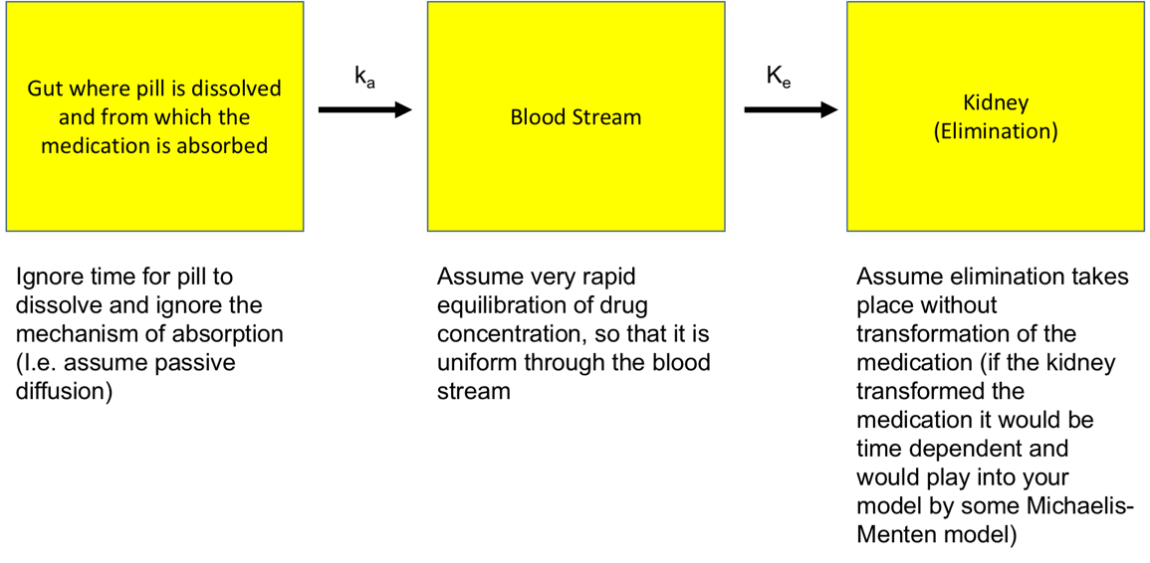
  - For this model use the following parameters:
volume of distribution (V_{d}) = 15 liters (15,000 ml),
absorption constant, k_{a} = 0.275
excretion constant, k_{e} = 0.25
dose = 1 gm =1 x 10⁶ mcg
bioavailability (F) = 95%
  - In addition to the above, on your submitted plot indicate:
    - the length of time from administration of metformin to peak plasma concentration,
    - time to half-life of the drug, i.e., total time from administration, through the peak, until the blood concentration returns to ½ peak concentration
    - duration of action.
  - As stated, metformin will diminish the hepatic production of glucose proportionately to its concentration. If one gram of metformin is ingested, the result will be that the hepatic production of glucose will be halved at peak drug concentration. Using the model developed above, make a model that links the time dependent concentration of metformin to the production of glucose by the liver. Submit your model and the plot of your outputs.
- The only drugs to treat type I diabetes mellitus is one of the multiple available forms of insulin (naturally occurring insulin from the pancreas of other animals - bovine or porcine, recombinant insulin, recombinant insulin modified to delay resorption or to increase the time of action by prolonging the attachment to the insulin receptors , etc.). Short acting recombinant human insulin (Humulin®) is injected subcutaneously. Peak blood concentrations are reached at about 45-75 minutes or 0.75 to 1.25 hours (your model ought to reach peak concentrations somewhere in that timeframe). Its duration of action is about 5 hours (again the serum concentration should start at zero and should be trending towards zero at about 5 hours). Half-life after reaching peak concentration is about ±3.
  - According to the literature from Eli Lilly, the manufacturer of Humulin:
  - the volume of distribution is about 0.3 L/Kg. For a 100 Kg individual (weight chosen for convenience) that comes to a V_{d} of 30 L.
  - Design a one compartment model for the insulin subcutaneous injection of 30 international units of insulin.
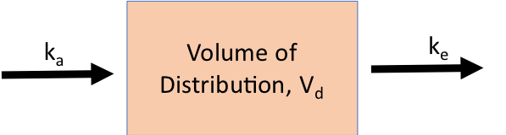
Eli Lilly gives the following parameters:
Constant of absorption = 1.55
Constant of excretion = 0.43
Bioavailability =0.65 (as per Lilly)
you will be giving a dose:
Dose = 30 IU = 3e4 mU (0.3 IU/Kg in a 100 Kg individual)
Volume of distribution 30 L
  - Now couple this model of insulin blood levels to the minimal glucose/insulin model and demonstrate what this injection does to the fasting blood sugar of a fasting type 1 diabetic. Remember a type 1 diabetic does not produce insulin. The model needs to be revised appropriately (see below). Make sure the pulse generator is reset to zero to simulate a fasting patient.
    - First, determine the fasting blood sugar in a type I diabetic. To do this set the parameters in the gains appropriately:
      - $β \left(controls insulin production\right)gain=0 υ \left(insulin dependence\right)gain=1$)
      - the initial insulin level in the insulin integrator is set to zero.
    - Run the model. Record the final glucose level (Steady state value). This will be the initial glucose level in your new model.
  - To couple the injection model to the minimal glucose/insulin model you need to realize a few things:
    - There is no longer a feedback between the glucose level and the insulin secretion. There is no production of insulin by the pancreas.
    - The insulin injection model you made has already considered with the k_{e} factor the destruction and elimination of insulin.
    - Your model for the injection of insulin has totally mapped the levels of insulin, i.e. the volume of distribution in the injection of insulin model replaces the capacitance of insulin in the minimal glucose/insulin model
    - Large parts of the minimal glucose/insulin model can be eliminated and replaced with the insulin injection model. This is what happens in type I diabetics. The feedback mechanisms to produce insulin and the control between insulin levels and glucose levels no longer exists. That is how type I diabetics get into serious medical emergencies. They risk severe, potentially fatal, hypoglycemia or hyperglycemic episodes with severe acidosis which are also potentially fatal.
  - Now use the model with the insulin injection coupled into the minimal glucose/insulin model. Run your simulation for the total duration of the drug – about 12 hours.
  - Study the glucose response in the simulation (show your plots and your model in your submission).
  - What is the half-life of insulin?
  - What is the glucose nadir?
  - Look up normal glucose levels and research what are considered low and dangerous glucose levels. What are they?
  - Research what occurs with low or dangerous glucose levels. Include these findings in your submission.
  - If significant hypoglycemia occurred in your model, how would the body react to counter the hypoglycemia? What other endocrine responses would you expect to occur (not accounted for in your model) before the blood sugar gets to these levels?
  - Remember that the simulation was an insulin injection on a fasting patient. When would you recommend that a diabetic patient inject Humulin: fasting or just before meals?

